Tree planting guidelines

- Choose a location. Choose an appropriate location to plant your tree.
Ideas:
  - West side of a home to eventually provide shade from the setting sun.
  - Near an HVAC unit to provide shade allowing the unit to operate more efficiently.
  - Near a sidewalk to provide shade for pedestrians and prevent reflective heat from the sun.
  - If you don’t have space in your yard contact info@soundforest.org and we can plant your tree for you.

- Removing grass. Score a circle in the sod with your shovel to remove the top layer of grass. (Approximately two feet in diameter) Remove sod from the surface where you will dig your hole by scalping grass and roots off the surface. (The grass roots are usually about 3 to 4 inches deep.)

NOTE! Place the grass in separate pile from the dirt you remove from the hole. You do not want to put grass and grass roots back in the hole when planting.

- Start digging! We recommend placing the soil in a bucket to make it easier to refill the hole once the tree is in place.

- Measure. Measure the depth of the hole and compare it to the size of the root system.

Note: The trunk flare is where the trunk of the tree turns into the root system. The trunk flare should be level with the surrounding ground once the tree is placed in the hole. Remove soil from the hole as needed until the hole is the proper depth.

- Place tree in hole. Place the root system of the tree into the hole. (One person can hold the tree and the other can fill the hole with the soil.)

- Backfill. Begin placing dirt around the root system and gently press it with your hands or foot to help prevent the tree from leaning. (Don’t worry if your tree is not standing exactly straight up and down. It will eventually grow straight!)

- Mulch. Place mulch over the soil. Approximately two inches in depth. Mulch will help retain moisture in the soil during the hotter times of the year. It will also help prevent the top layer of soil from being compacted from the rain. Note: Mulch doesn’t have to be purchased from a store. Gathering pine needles or leaves that have fallen from a tree will also work great!

- Protection. Consider placing a corrugated plastic drain pipe or cut the top off a plastic bottle and place around the base of the tree to prevent weed trimmers from destroying the tree. Make sure to score one side of the plastic to allow for the tree to grow and expand over time.

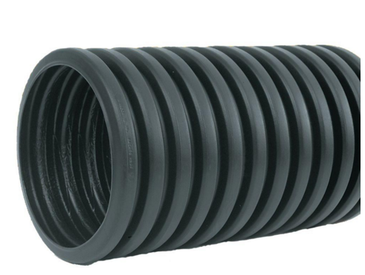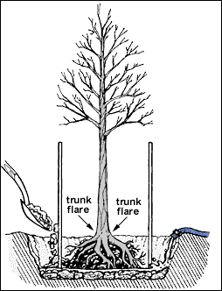
Instagram: @soundforestorg

